There is a SwiftReach SwiftK12 link in the Parent and Student Portal where guardians can access Alerts, view their Contact Information and update their Alert Preferences.

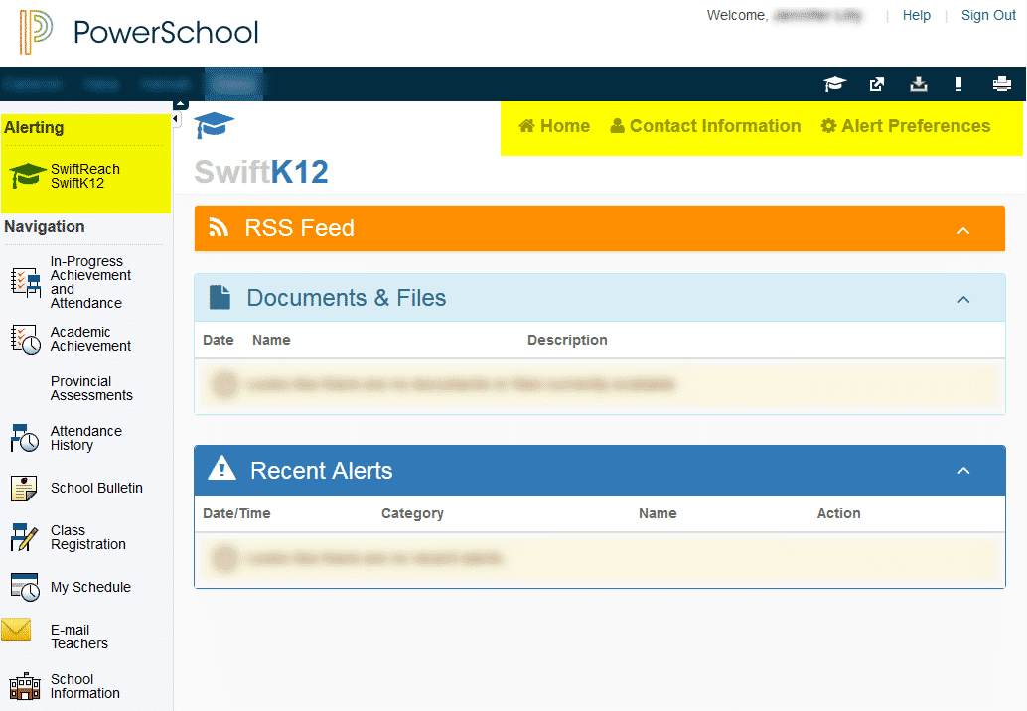
After clicking on1 the SwiftReach SwiftK12 link parents have three pages they can view:
- Home
- Contact Information
- Alert Preferences
Contact Information is where parents can view their Basic Information for the messaging system which is their demographic information in PowerSchool. Parents/guardians should contact the main office of the school to update demographic information such as phone numbers and email addresses if what they see is incorrect.

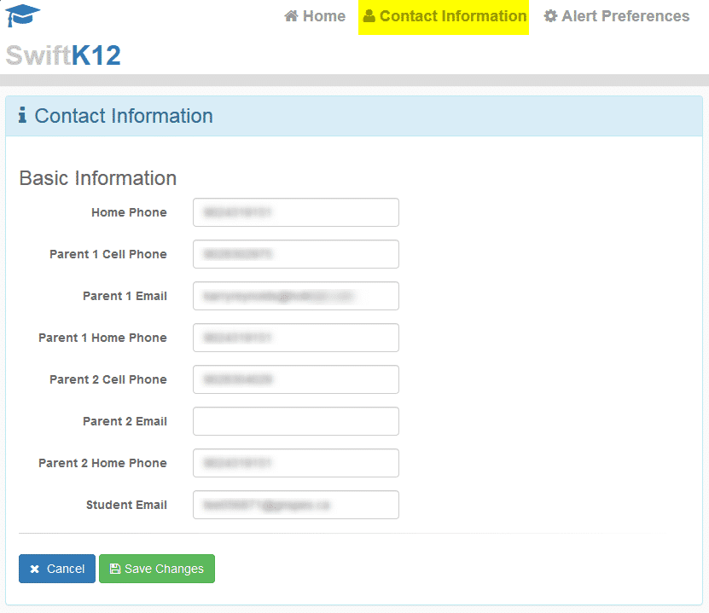
This is what parents see in the Portal when they click Contact Information.

NOTE: Parents/guardians cannot make changes on this screen. Parents/guardians should contact the main office of the school to update demographic information such as phone numbers and email addresses if what they see is incorrect.

Alert Preferences is where parents can set which contact number and/or email address they prefer for Attendance (if applicable) and General Information alerts:
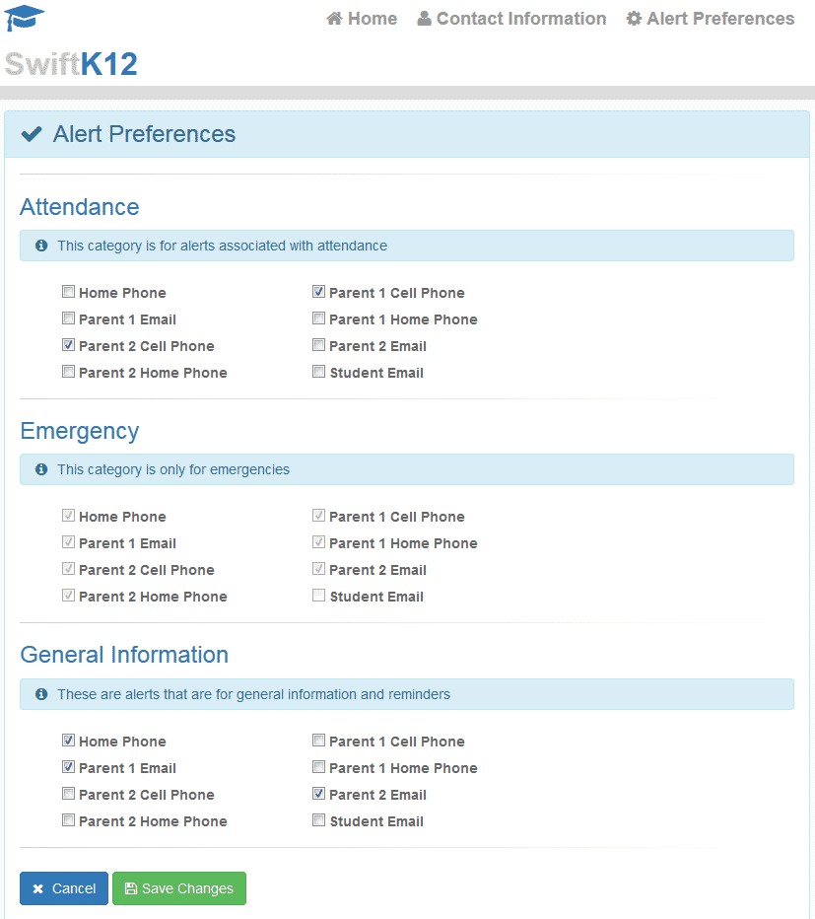

This is what parents see in the Portal when they click Alert Preferences. Parents can make changes to how they are contacted by the messaging system. School staff with SwiftK12 security can make changes to this page for parents/guardians as well.

